Title of Paper Should Be Typed with Bold Times Font type Centered with 14-point size
A. Lastname¹, B. C. Familname¹ and D. E. Surname²

¹Institute of XYZ Studies, University of PQR, LMNO – 555555
²Department of Physics, University of RST, GHIJ – 8888888
Abstract
Author’s name should be centered 12-point Times Font type. Author’s name should be in order of given name, middle name initial and family name. Underline the presenting author. The affiliation of authors should be in Times Font 10 point italics and centered. The abstract should be 10 point justified type with a 5 mm indentation (both of left and right) and within the 200-word limit. It should be an explicit summary of the paper that states the problem, the methods used, and the major results and conclusions. It should also contain relevant key words that would allow it to be found in a cursory computerized search.
1. Introduction
This document is a journal-page image for Microsoft Word versions 6.0 or later. Author/s may use this file to check the manuscript in a printed image, equations (especially lengthy equations to be separated into multiple lines), tables and figures (font sizes should be checked), and references. Please use Times/Times Roman font.
Paper size should be A4 (21.0 x 29.7 cm). Margins should be taken 3.8 cm for top and bottom and 3.5 cm for left and right. Main text is in two-column format. All fonts for text should be Times or Times New Roman and Symbol. Text should be 10 pt., the title should be 14 pt., and the affiliation and references should be 10 pt. Do not use hyphenations for the end of a line. The line space of main text should be 13 pt., while that of Title should be 22 pt.
Major headings (“Head 1” in the template style list) are bold 11-point font, flush left, and numbered (1. 2. 3. etc.) Subheadings and Sub-Subheadings are bold, flush left, and numbered as 1.1, 1.2, etc. and as 1.1.1, 1.1.2, etc., respectively. The first line of paragraphs should be indented 7 mm.
Do not change the font sizes or line spacing to squeeze more text into a limited number of pages. In footnotes section, you are requested to write corresponding author’s e-mail address.

2. Equations and Figures
Use either the Microsoft Equation Editor for all math objects in your paper. "Float over text" should not be selected. A math object is any equation or fragment containing mathematical symbols (including Greek characters, superscripts and subscripts) that appears either in-line (in the flow of normal text) or as a display equation (in its own space between lines of text).
In particular, you should avoid using Word fonts or symbols for in-line single variables with superscripts or subscripts. Use italics for emphasis; do not underline.
Equations should be indented 10 mm. Equation numbers should appear at the right-hand margin, in parenthesis. For long equations, the equation number may appear on the next line. For very long equations, the right side of the equation should be broken into approximately equal parts and aligned to the right of the equal sign. The equation number should appear only at the right hand margin of the last line of the equation. For example,

(1)
where.
(2)

Figures should be included directly in the document. All photographs must be in digital form and placed appropriately in the electronic document. All illustrations must be numbered consecutively with Arabic numbers. The size of a figure should be commensurate with the amount and value of the information conveyed by the figure.
Place figure captions below the figures. The captions should be indented no margins. The abbreviation “Fig.” for figure should appear first followed by the figure number and a period. Captions should be in 9 pt. Roman Font.
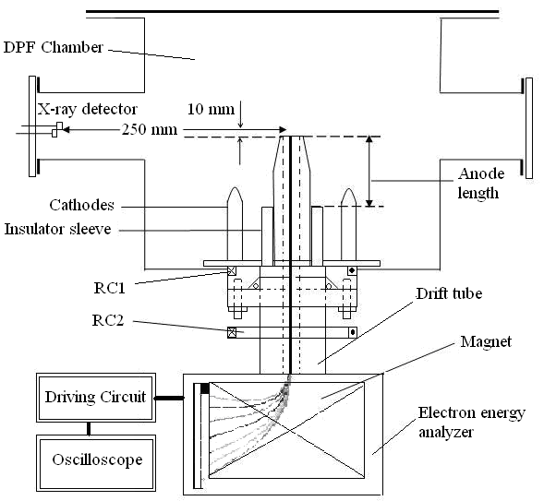
Fig.1 Sample figure to get the idea.

3. References
The paper should follow the following citation style: For journal articles, authors are listed first, the volume number in bold, inclusive page numbers, and the year in parentheses.
References should appear at the end of the article. The font should be 9 pt., aligned left. The words “References” should not head. All references should be indented no margin, with succeeding lines indented sufficiently to preserve alignment. The line space of this part should be 12 pt.
At the point of citation within the main text, designate the reference by typing the number in after the last corresponding word [1]. Reference numbers should precede a comma or period [2]. Two references [3,4], should be included together, separated by a comma, while three or more consecutive references should be indicated by the bounding numbers and a dash [3-6].

- L. Spitzer, Jr., Physics of Fully Ionized Gases (Interscience Publishers, New York, 1959) p. 20.
- J. M. Koh, R. S. Rawat, A. Patran, T. Zhang, D. Wong, S. V. Springham, T. L. Tan, S. Lee, and P. Lee, Plasma Sources Sci. Technol. 14, 12-18 (2005).
- M. Zakaullah, G. Murtaza, I. Ahmad, F. N. Beg, M. M. Beg, and M. Shabbir, Plasma Sources Sci. Technol. 4, 117-124 (1995).
- R. K. Rout, A. B.Garg, A. Shyam, and M. Srinivasan, IEEE Trans. Plasma Sci. 23, 996 (1995).
- A. Gribkov, Ph.d Thesis, in Physical and Mathematical Sciences, PN Lebedev Physical Institute, Russian Academy of Sciences: Moscow (1991).
- T. S. Kobata, Plasma Phys. Contrl. Fusion 26, 575-584 (1984).

